CIRCULATION PAST PAPERS

Parts (c), (d) and (e) of the question refer to the diagram of the heart below.

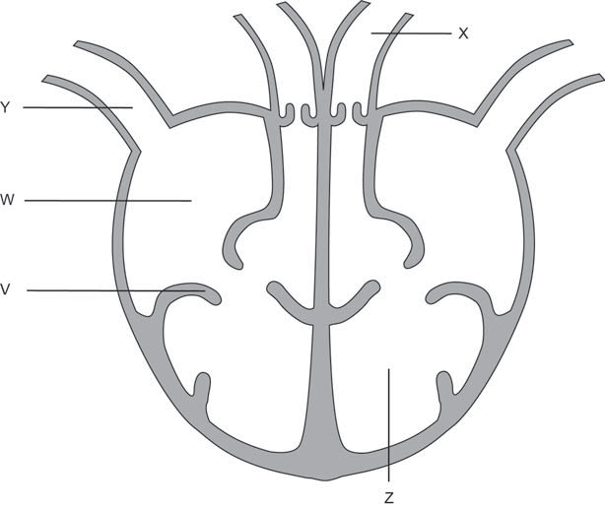

1. Identify the structures labelled ‘W’ and ‘Z’. (2 marks)

W:

Z:

1. Describe the role of the structure labelled ‘V’ on the diagram. (1 mark)
2. Compare the vessels labelled ‘X’ and ‘Y’ by completing the table below. (4 marks)

|  |  |  |
| --- | --- | --- |
|  | **Vessel X** | **Vessel Y** |
| **Structure** |  |  |
| **Function** |  |  |

# Question 39 (20 marks)

1. Outline the pathway taken by a red blood cell through the heart. Start at the point where blood returns to the heart via the vena cava and finish where blood leaves the heart via the aorta. Include in your answer the events that occur along the pathway. (12 marks)
2. Describe **four** key structural or functional features of arteries and describe **four** key structural or functional features of veins. (8 marks)